Paper Presentation:

**Safety Techniques for School Bus Drivers**

Presented at

**2024 Federal Road Safety Corps Mandatory Training Workshop for Drivers**

**By**

**ALABI RAZAQ**

Chief Route Commander

Topic: **Safety Techniques for School Bus Drivers**

**Introduction**

School bus drivers have a significant responsibility in ensuring the safety and security of students during their commute. This is especially important in the current security and social economic situation of Nigeria, where we face unique challenges such as rampant kidnapping, bad road conditions, untrained and reckless drivers, and other road safety issues. Drivers must adopt proper safety techniques to protect students and pupils and ensure that their journeys are as safe as possible.

This paper will discuss three major subtopics: Basic Vehicle Daily Drills, Techniques for Protection of Students in School Buses, and Traffic Drill Precautions. Each section will highlight how these techniques help reduce risks and ensure safe transportation.

**PART 1. BASIC VEHICLE DAILY DRILLS**

The first step to safety begins with proper vehicle maintenance and inspection before starting any journey, regardless of the destination distance. A daily check of the school bus is critical in preventing mechanical failures that can cause accidents or leave the bus vulnerable to external dangers.

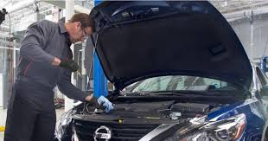

**Key Drills for Daily Vehicle Inspection:**

**Tire Pressure and Condition**: Ensure tires are properly inflated and free of wear or damage. Bad tires increase the risk of skidding, especially on bad roads. Recommended tire pressures for every vehicle can be found in owner’s manual or on a sticker on the vehicle door. Under inflated tires can cause blow outs while over inflated tires can reduce tire grip and breaking efficiency.

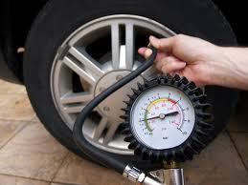

**Brakes Check**: The brake system should be inspected daily. Faulty brakes are a significant cause of road crashes, particularly when navigating through congested or poorly maintained roads.

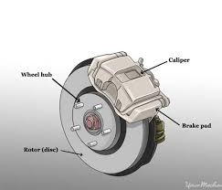

**Lights and Signals**: Check all lights, including headlights, brake lights, and turn signals, to ensure they are functioning correctly. In areas with untrained drivers, clear signaling reduces misunderstandings and accidents.



**Mirrors and Windows**: Ensure all mirrors provide a clear view of the surroundings, and windows should be free of obstructions. Visibility is critical for the driver to detect potential hazards early.

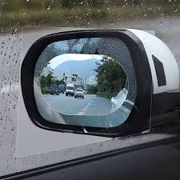

**Seatbelt Functionality**: All seatbelts should be operational, as wearing them reduces the impact in case of a crash. Ensure students use them.

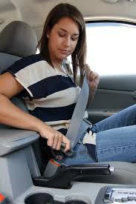

**Emergency Kit and Fire Extinguisher**: Every school bus should have a functional fire extinguisher and a first aid kit to respond to emergencies, especially in remote areas.

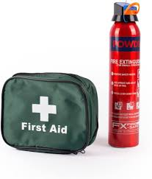

**PART 2. TECHNIQUES FOR PROTECTION OF STUDENTS AND PUPILS IN SCHOOL BUS**

Given the current security challenges in Nigeria, such as rampant kidnappings, school bus drivers must be trained in techniques to protect the children under their care.

**Key Safety Techniques**:

**Controlled Access to the Bus**: Drivers must ensure that only authorized persons (teachers, caregivers, parents) are allowed to board or approach the bus. Where possible, school buses should be fitted with automatic doors that the driver controls to prevent unauthorized entry.



**Bus Route Planning**: Plan bus routes to avoid high risk areas such as isolated roads, crime prone areas, and locations with poor road conditions. Using well lit and highly trafficked roads reduces the chance of kidnappings and road accidents.

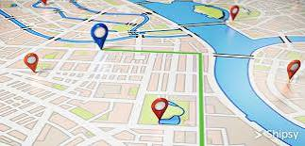

**Close Supervision at Stops**: Always ensure that students are accompanied while boarding and disembarking. A vigilant driver can prevent children from wandering into unsafe areas or being left behind.

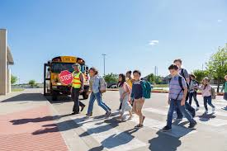

**Emergency Response Training**: In case of security threats or accidents, drivers should be trained to remain calm and take immediate protective measures. This could include contacting emergency services or finding a secure location for the children. Drivers are advised to have emergency phone numbers of Police, FRSC and Nigerian Army operatives handy.

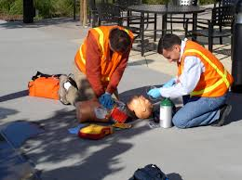

**Avoid Overloading**: Overloading is dangerous for several reasons. It makes the bus more difficult to control, increases the risk of mechanical failure, and in the event of an accident, more students could be injured. Always adhere to the recommended capacity of the bus, and ensure every child has a proper seat.

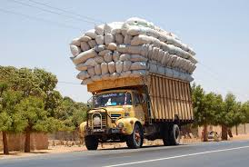

**PART 3. TRAFFIC DRILL PRECAUTIONS**

Navigating Nigerian roads requires special attention to traffic rules, especially with the mix of well trained and reckless drivers. The risks of bad road segments, such as potholes and washed out roads, make caution even more necessary.

**Key Traffic Drill Techniques:**

**Speed Management**: Always maintain a safe speed, especially when driving on rough or narrow roads. Speeding can lead to losing control of the vehicle, particularly with a full load of students.



**Safe Following Distance**: Maintain a safe distance from other vehicles. This allows for better reaction time in case the vehicle in front stops abruptly, which is common with reckless drivers.

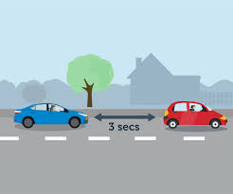

**Alertness at Intersections**: Many Nigerian drivers do not obey traffic lights or rules at intersections. Be extra vigilant and ensure that the way is clear before crossing or turning.

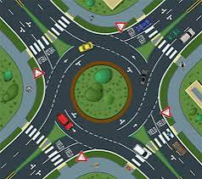

**Potholes and Obstacles**: Drive slowly through bad road segments. Sudden maneuvers to avoid potholes could lead to loss of control. Communicate with the children to remain seated and calm when approaching rough areas.

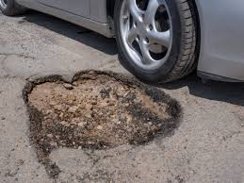

**Driver Fatigue and Breaks**: Fatigue can impair judgment and reaction time. Drivers should take breaks when necessary and avoid driving long hours without rest. A tired driver is more likely to cause an accident.



**Conclusion**

The safety of school bus transportation depends heavily on the diligence and awareness of the driver. By following these basic vehicle checks, employing techniques to protect students, and adhering to traffic precautions, school bus drivers can significantly reduce the risk of accidents, kidnapping, and other incidents. The life of each child in the school bus is precious, and it is the driver’s responsibility to ensure their journey is safe and secure every day.

Through proper training and adherence to these safety techniques, Nigerian school bus drivers can create a safer environment on the roads for everyone.

**References**

*1.* ***Federal Road Safety Corps (FRSC) Guidelines for Commercial Drivers***

*- FRSC, Nigeria. “Guidelines for Safe Driving Practices.” Accessed from FRSC official publications and training materials.*

*2.* ***National Highway Traffic Safety Administration (NHTSA) – School Bus Safety Guidelines.***

*- NHTSA, U.S. Department of Transportation. “School Bus Safety.” Published online,* [*www.nhtsa.gov*](http://www.nhtsa.gov)*. Accessed October 2023.*

*3.* ***International Association for Driver Education (IVV) – Best Practices for School Bus Drivers.***

*- International Association for Driver Education. “Driver Training and Road Safety Best Practices.” Published 2023.*

*4.* ***Tire Pressure Monitoring Systems (TPMS) & Tire Safety****.*

*- Bridgestone Tire. “Tire Safety and Maintenance Guidelines.” Bridgestone Safety Publications, 2022.* [*www.bridgestone.com*](http://www.bridgestone.com)*.*

*5. Safe* ***Routes to School – Protecting Students in Transit***

*- National Center for Safe Routes to School. “School Bus Safety and Student Protection Techniques.” 2022.* [*www.saferoutesinfo.org*](http://www.saferoutesinfo.org)*.*

*6.* ***World Health Organization (WHO) – Road Safety Reports***

*- WHO. “Global Status Report on Road Safety.” Geneva: World Health Organization, 2021.*